AVR Micro Controller

The AVR is a modified Harvard architecture 8-bit RISC single chip microcontroller which was developed by Atmel in 1996. The AVR was one of the first microcontroller families to use on-chip flash memory for program storage, as opposed to One-Time Programmable ROM, EPROM, or EEPROM used by other microcontrollers at the time.
The AVR architecture was conceived by two students at the Norwegian Institute of Technology (NTH) Alf-Egil Bogen and Vegard Wollan.
The original AVR MCU was developed at a local ASIC house in Trondheim, Norway called Nordic VLSI at the time, now Nordic Semiconductor, where the two founders of Atmel Norway were working as students. It was known as a μRISC (Micro RISC) and was available as silicon IP/building block from Nordic VLSI. When the technology was sold to Atmel from Nordic VLSI, the internal architecture was further developed by Alf and Vegard at Atmel Norway, a subsidiary of Atmel founded by the two architects. The designers worked closely with compiler writers at IAR Systems to ensure that the instruction set provided for more efficient compilation of high-level languages. Atmel says that the name AVR is not an acronym and does not stand for anything in particular. The creators of the AVR give no definitive answer as to what the term "AVR" stands for.
Note that the use of "AVR" in this article generally refers to the 8-bit RISC line of Atmel AVR Microcontrollers.
Among the first of the AVR line was the AT90S8515, which in a 40-pin DIP package has the same pin out as an 8051 microcontroller, including the external multiplexed address and data bus. The polarity of the RESET line was opposite (8051's having an active-high RESET, while the AVR has an active-low RESET), but other than that, the pin out was identical.
- The AVR is a modified Harvard architecture machine with program and data stored in separate physical memory systems that appear in different address spaces, but having the ability to read data items from program memory using special instructions.

Basic families
AVRs are generally classified into five broad groups:
- tinyAVR — the ATtiny series
  - 0.5–8 kB program memory
  - 6–32-pin package
  - Limited peripheral set
- megaAVR — the ATmega series
  - 4–256 kB program memory
  - 28–100-pin package
  - Extended instruction set (Multiply instructions and instructions for handling larger program memories)
  - Extensive peripheral set
- XMEGA — the ATxmega series
  - 16–384 kB program memory
  - 44–64–100-pin package (A4, A3, A1)
  - Extended performance features, such as DMA, "Event System", and cryptography support.
  - Extensive peripheral set with DACs
- Application specific AVR
  - megaAVRs with special features not found on the other members of the AVR family, such as LCD controller, USB controller, advanced PWM, CAN etc.
- FPSLIC™ (AVR with FPGA)

Features of ATMEGA32:

High-performance, Low-power AVR® 8-bit Microcontroller
• Advanced RISC Architecture
– 131 Powerful Instructions – Most Single-clock Cycle Execution
– 32 × 8 General Purpose Working Registers
– Fully Static Operation
– Up to 16 MIPS Throughput at 16 MHz
– On-chip 2-cycle Multiplier
• High Endurance Non-volatile Memory segments
– 32 Kbytes of In-System Self-programmable Flash program memory
– 1024 Bytes EEPROM
– 2 Kbytes Internal SRAM
– Write/Erase Cycles: 10,000 Flash/100,000 EEPROM
– Data retention: 20 years at 85°C/100 years at 25°C
– Optional Boot Code Section with Independent Lock Bits
In-System Programming by On-chip Boot Program
True Read-While-Write Operation
– Programming Lock for Software Security
• JTAG (IEEE std. 1149.1 Compliant) Interface
– Boundary-scan Capabilities According to the JTAG Standard
– Extensive On-chip Debug Support
– Programming of Flash, EEPROM, Fuses, and Lock Bits through the JTAG Interface
• Peripheral Features
– Two 8-bit Timer/Counters with Separate Prescalers and Compare Modes
– One 16-bit Timer/Counter with Separate Prescaler, Compare Mode, and Capture
Mode
– Real Time Counter with Separate Oscillator
– Four PWM Channels
– 8-channel, 10-bit ADC
8 Single-ended Channels
7 Differential Channels in TQFP Package Only
2 Differential Channels with Programmable Gain at 1x, 10x, or 200x
– Byte-oriented Two-wire Serial Interface
– Programmable Serial USART
– Master/Slave SPI Serial Interface
– Programmable Watchdog Timer with Separate On-chip Oscillator
– On-chip Analog Comparator
• Special Microcontroller Features
– Power-on Reset and Programmable Brown-out Detection
– Internal Calibrated RC Oscillator
– External and Internal Interrupt Sources
– Six Sleep Modes: Idle, ADC Noise Reduction, Power-save, Power-down, Standby
and Extended Standby
• I/O and Packages
– 32 Programmable I/O Lines
– 40-pin PDIP, 44-lead TQFP, and 44-pad QFN/MLF
• Operating Voltages
– 2.7V - 5.5V for ATmega32L
– 4.5V - 5.5V for ATmega32
• Speed Grades
– 0 - 8 MHz for ATmega32L
– 0 - 16 MHz for ATmega32
• Power Consumption at 1 MHz, 3V, 25°C for ATmega32L
– Active: 1.1 mA
– Idle Mode: 0.35 mA
– Power-down Mode: < 1 μA

Pin Diagram of ATMEGA 32

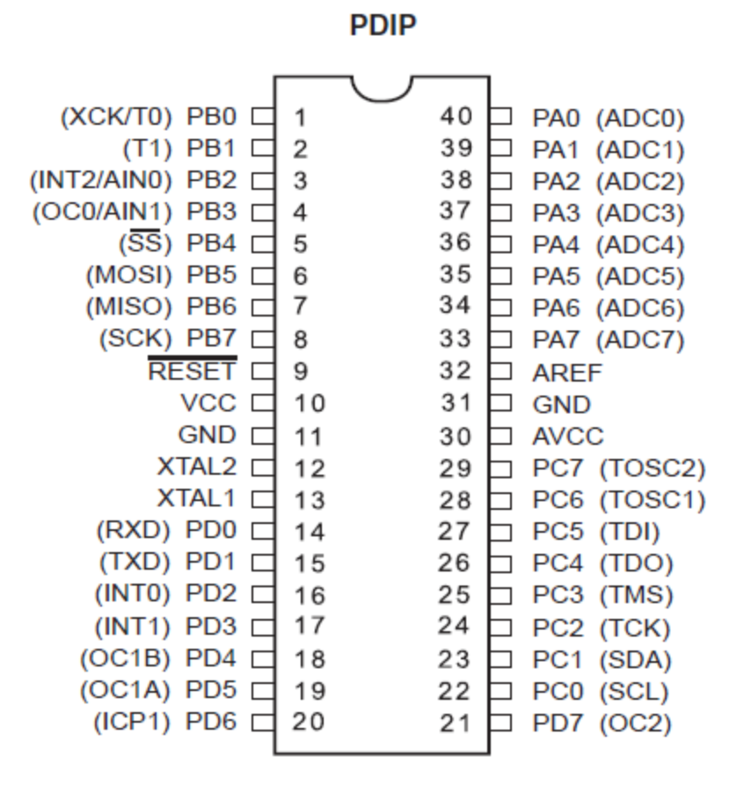

Basic Pins

VCC Digital supply voltage.
GND Ground.
Port A (PA7….PA0) Port A serves as the analog inputs to the A/D Converter.

Port A also serves as an 8-bit bi-directional I/O port, if the A/D Converter is not used. Port pins can provide internal pull-up resistors (selected for each bit). The Port A output buffers have symmetrical drive characteristics with both high sink and source capability. When pins PA0 to PA7 are used as inputs and are externally pulled low, they will source current if the internal pull-up resistors are activated. The Port A pins are tri-stated when a reset condition becomes active, even if the clock is not running.

Port B (PB7..PB0) Port B is an 8-bit bi-directional I/O port with internal pull-up resistors (selected for each bit).

The Port B output buffers have symmetrical drive characteristics with both high sink and source capability. As inputs, Port B pins that are externally pulled low will source current if the pull-up resistors are activated. The Port B pins are tri-stated when a reset condition becomes active, even if the clock is not running. Port B also serves the functions of various special features of the ATmega32 as listed on page

Port C (PC7..PC0) Port C is an 8-bit bi-directional I/O port with internal pull-up resistors (selected for each bit).

The Port C output buffers have symmetrical drive characteristics with both high sink and source capability. As inputs, Port C pins that are externally pulled low will source current if the pull-up resistors are activated. The Port C pins are tri-stated when a reset condition becomes active, even if the clock is not running. If the JTAG interface is enabled, the pull-up resistors on pins PC5(TDI), PC3(TMS) and PC2(TCK) will be activated even if a reset occurs. The TD0 pin is tri-stated unless TAP states that shift out data are entered. Port C also serves the functions of the JTAG interface.

Port D (PD7..PD0) Port D is an 8-bit bi-directional I/O port with internal pull-up resistors (selected for each bit).

The Port D output buffers have symmetrical drive characteristics with both high sink and source capability. As inputs, Port D pins that are externally pulled low will source current if the pull-up resistors are activated. The Port D pins are tri-stated when a reset condition becomes active, even if the clock is not running. Port D also serves the functions of various special features of the ATmega32.

RESET Reset Input. A low level on this pin for longer than the minimum pulse length will generate a reset, even if the clock is not running. Shorter pulses are not guaranteed to generate a reset.

XTAL1 Input to the inverting Oscillator amplifier and input to the internal clock operating circuit.

XTAL2 Output from the inverting Oscillator amplifier.

AVCC AVCC is the supply voltage pin for Port A and the A/D Converter. It should be externally connected to VCC, even if the ADC is not used. If the ADC is used, it should be connected to VCC through a low-pass filter.

AREF AREF is the analog reference pin for the A/D Converter.

Memory Organization
In-System Reprogrammable Flash Program Memory

The ATmega32 contains 32 Kbytes On-chip In-System Reprogrammable Flash memory for program storage. Since all AVR instructions are 16 or 32 bits wide, the Flash is organized as 16K × 16. For software security, the Flash Program memory space is divided into two sections, Boot Program section and Application Program section.

The Flash memory has an endurance of at least 10,000 write/erase cycles. The ATmega32 Program Counter (PC) is 14 bits wide, thus addressing the 16K program memory locations.

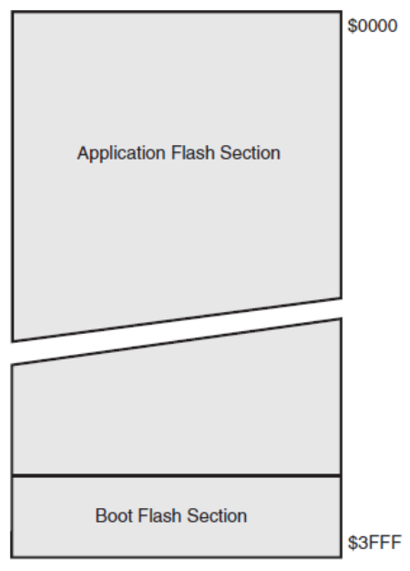
SRAM DataMemory

The lower 2144 Data Memory locations address the Register File, the I/O Memory, and the internal data SRAM. The first 96 locations address the Register File and I/O Memory, and the next 2048 locations address the internal data SRAM.

The five different addressing modes for the data memory cover: Direct, Indirect with Displacement, Indirect, Indirect with Pre-decrement, and Indirect with Post-increment. In the Register File, registers R26 to R31 feature the indirect Addressing Pointer Registers. The direct addressing reaches the entire data space. The Indirect with Displacement mode reaches 63 address locations from the base address given by the Y- or Z-register.

When using register indirect addressing modes with automatic pre-decrement and post-increment, the address registers X, Y, and Z are decremented or incremented. The 32 general purpose working registers, 64 I/O Registers, and the 2048 bytes of internal data
SRAM in the ATmega32 are all accessible through all these addressing modes.

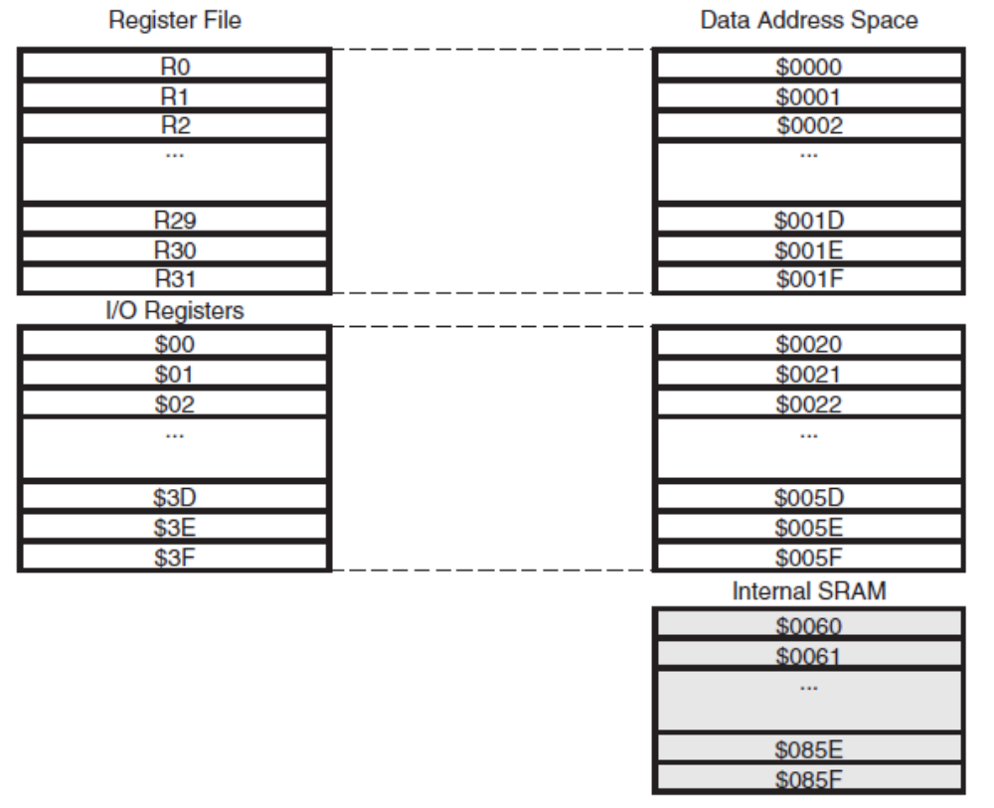

Data Memory Access Times

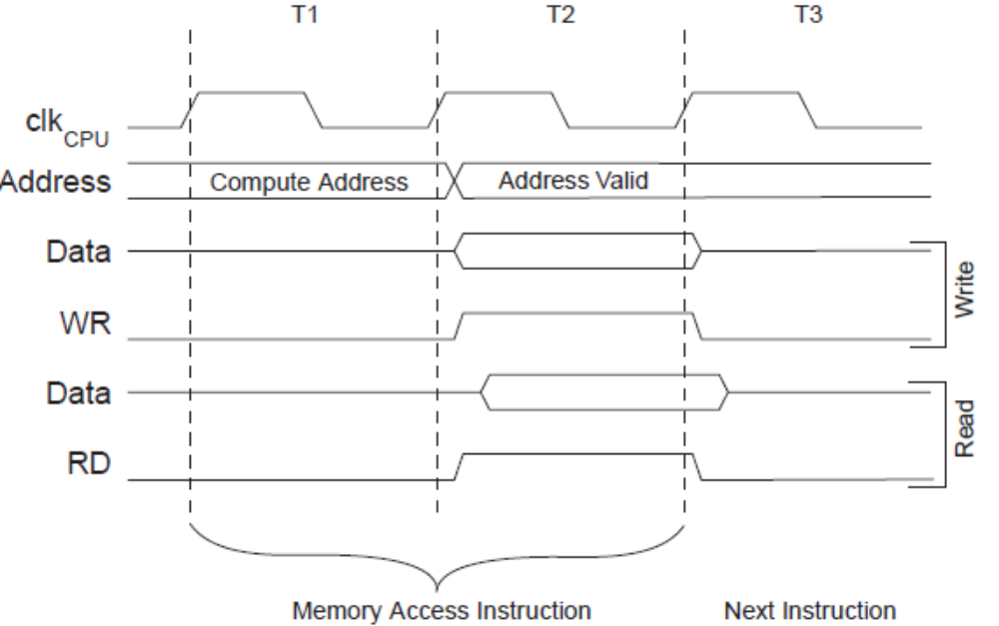
EEPROM Data Memory
The ATmega32 contains 1024 bytes of data EEPROM memory. It is organized as a separate data space, in which single bytes can be read and written. The EEPROM has an endurance of at least 100,000 write/erase cycles. The access between the EEPROM and the CPU is described in the following, specifying the EEPROM Address Registers, the EEPROM Data Register, and the EEPROM Control Register.

EEPROM Read/Write Access
The EEPROM Access Registers are accessible in the I/O space. The write access time for the EEPROM is given in Table 1. A self-timing function, however, lets the user software detect when the next byte can be written. If the user code contains instructions that write the EEPROM, some precautions must be taken. In heavily filtered power supplies, VCC is likely to rise or fall slowly on Power-up/down. This causes the device for some period of time to run at a voltage lower than specified as minimum for the clock frequency used.
When the EEPROM is read, the CPU is halted for four clock cycles before the next instruction is executed. When the EEPROM is written, the CPU is halted for two clock cycles before the next instruction is executed.

The EEPROM Address Register – EEARH and EEARL

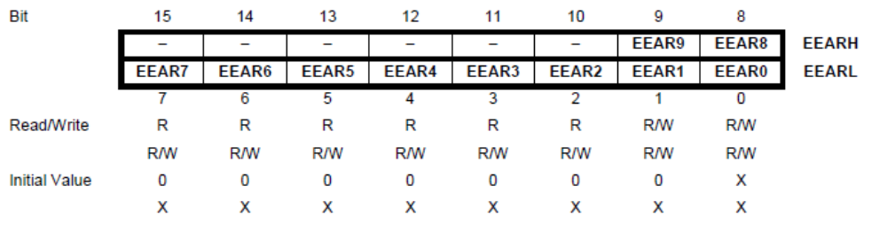
• Bits 15..10 – Res: Reserved Bits
These bits are reserved bits in the ATmega32 and will always read as zero.

• Bits 9..0 – EEAR9..0: EEPROM Address
The EEPROM Address Registers – EEARH and EEARL – specify the EEPROM address in the 1024 bytes EEPROM space. The EEPROM data bytes are addressed linearly between 0 and 1023. The initial value of EEAR is undefined. A proper value must be written before the EEPROM may be accessed.

The EEPROM Data Register – EEDR
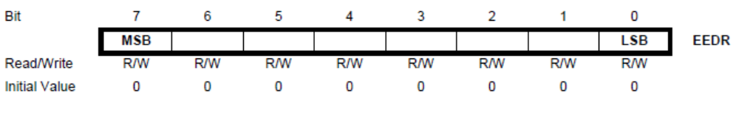
• Bits 7..0 – EEDR7.0: EEPROM Data
For the EEPROM write operation, the EEDR Register contains the data to be written to the EEPROM in the address given by the EEAR Register. For the EEPROM read operation, the EEDR contains the data read out from the EEPROM at the address given by EEAR.

The EEPROM Control Register – EECR

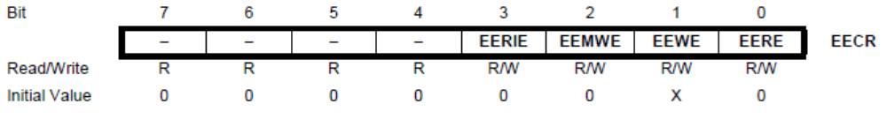
• Bits 7..4 – Res: Reserved Bits
These bits are reserved bits in the ATmega32 and will always read as zero.

• Bit 3 – EERIE: EEPROM Ready Interrupt Enable
Writing EERIE to one enables the EEPROM Ready Interrupt if the I bit in SREG is set. Writing
EERIE to zero disables the interrupt. The EEPROM Ready interrupt generates a constant interrupt when EEWE is cleared.

• Bit 2 – EEMWE: EEPROM Master Write Enable
The EEMWE bit determines whether setting EEWE to one causes the EEPROM to be written. When EEMWE is set, setting EEWE within four clock cycles will write data to the EEPROM at
the selected address If EEMWE is zero, setting EEWE will have no effect. When EEMWE has been written to one by software, hardware clears the bit to zero after four clock cycles.

• Bit 1 – EEWE: EEPROM Write Enable
The EEPROM Write Enable Signal EEWE is the write strobe to the EEPROM. When address and data are correctly set up, the EEWE bit must be written to one to write the value into the EEPROM. The EEMWE bit must be written to one before a logical one is written to EEWE, otherwise no EEPROM write takes place.

• Bit 0 – EERE: EEPROM Read Enable
The EEPROM Read Enable Signal – EERE – is the read strobe to the EEPROM. When the correct address is set up in the EEAR Register, the EERE bit must be written to a logic one to trigger the EEPROM read. The EEPROM read access takes one instruction, and the requested data is available immediately. When the EEPROM is read, the CPU is halted for four cycles Before the next instruction is executed. The user should poll the EEWE bit before starting the read operation. If a write operation is in progress, it is neither possible to read the EEPROM, nor to change the EEAR Register.

